Learning With Cases

Part 1: 如何分析案例
Part 2: 案例教学的独特作用
Part 3: 如何在案例教学中取得成功

Part 1: 如何分析案例

A generic approach to case solving includes the following steps:
- Defining the issue;
- Analyzing the case data with focus on causes and effects as well as constraints and opportunities;
- Generating alternatives;
- Selecting decision criteria;
- Analyzing and evaluating alternatives;
- Selecting the preferred alternative;
- Developing an action and implementation plan.
Note that some parts of this model will not apply to every case.

A .Defining the Issue
Your initial job in case analysis is to develop a clear and comprehensive statement of the issue(s) involved in the case.
The key concern(s), problem(s), decision(s), challenge(s) or opportunity(ies) you are facing as main actor of the case need to be clearly identified.
Immediate and Basic Issues
The immediate issue refers to the specific decision, problem, challenge or opportunity faced by the decision maker in the case. For example, the decision focus may be on the purchase of software, where several options are available. The decision as to which of the software options to purchase is the immediate issue. Basic issues are larger and more generic in nature. They relate to the conceptual content and design of the course. Tor example, a basic issue in the software case might be “make or buy” Another could be the design of information systems. Yet another could be organizational roles and responsibilities: How much influence should the user of a software package have over this kind of purchase versus the chief in formation officer or the purchasing manager?
Importance v.s. Urgency
One of the first judgments that need to be made about the case issue is whether this issue is of strategic importance to the organization or not. Could it make or break the organization? Could it be a source of major competitive advantage? Could it impact the profitability significantly? Could it have a major effect on the morale of the employees or on the corporate image?
As part of the first step of defining the issue, a feeling for the sense of urgency is fundamental to effective case analysis.
The combination of importance and urgency places the case issue on a priority list and will affect the criteria for decision making, the resources that should be used, including the amount of money that can be spent, and the options which may be considered to resolve it. That is why putting the issue in context early is vital to effective case analysis.

B. Analyzing Case Data
The problem solving aspect of case analysis is often concerned with causes and effects.
Causes and Effects. Problems cannot be solved unless their causes have been identified. Establishing the cause of problems is not always easy and may require you to think about relationships between events as well as between people to sort out causes from effects.
In operations management the Causes and Effect or Fishbone Diagram is particularly useful to identify causes and effects. It normally separates causes into relevant categories, for example , a five category diagram could include (1) people, (2)equipment and facilities, (3) methods and systems, (4) materials, and (5) other as show in Exhibit3-5.
Constraints and Opportunities. You should also identify constraints or opportunities which will impact on your analysis and ultimately on your recommendations. Constraints and opportunities are not always explicit in the case, although they may be implied by the environmental context, or the date and location of the case.
Consider the key resources of an organization to be money, people, materials, equipment, facilities and the management system. Each of these resources or a combination of them can be a constraint or an opportunity.
Quantitative and qualitative Assessment. Almost every case has quantitative as well as qualitative dimensions. Frequently, students prefer the qualitative over the quantitative. Please try to avoid this inclination .Push the numbers, play with the numbers and you may get a much better feel for the whole situation. The use of computers has made the pushing of numbers relatively easy. One has to be careful however not to get lost in detailed numerical analysis with little reflection about what these numbers actually mean.

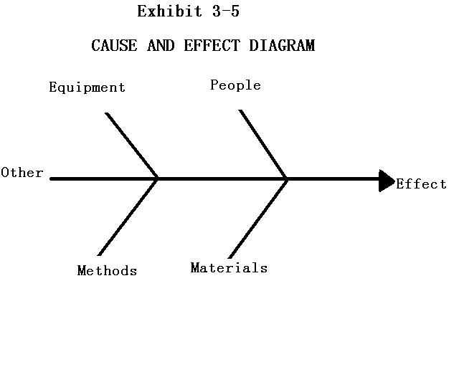
C. Generating Alternatives
The next part of the case solving process deals with trying to remove the cause(s) of the problem(s) by developing a number of different ways to address the issue(s) of the case. Now is the time to be creative and think widely. If an alternative is not part of the original set which will be analyzed, all further work on the decision will ignore the missed alternative’s potential.
When you are formulating different alternatives, consider constraints and opportunities that you have identified in the preceding data analysis phase. Refer to your own knowledge or past experience as well as to any theory gleaned from your readings. Make your alternatives realistic and plausible in view of your causal analysis and understanding of the issue(s).

D. Selecting Decision Criteria
Before choosing one or a combination of your alternatives, it is important that you clearly define the criteria against which to compare all possible alternatives. Decision criteria provide the basis for evaluation or assessment measures. They are the standards by which alternatives may be evaluated and compared.
Decision criteria can be classified as quantitative as well as qualitative. Exhibit 3-6 gives a list of frequently used criteria. The list of criteria is not exhaustive and, under certain circumstances, items list under the left hand column of Exhibit 3-6 might well move to the right and vice versa. Ease of measurement and quantification under the circumstances of the specific case being analyzed will determine whether the criterion is qualitative or quantitative.

Exhibit 3-6
LIST OF COMMON DECISION CRITERIA
QUANTITATIVE | QUALITATIVE
profit | Competitive advantage
Cost | Customer satisfaction
Return on investment | Employee morale
Market share | Corporate
Capacity | Ease of implementation
Delivery time | Synergy
Risk | Ethics
Cash flow | Flexibility
Inventory turn | Safety
Productivity | Visual appeal
Staff turnover | Obsolescence
Quality | Cultural sensitivity
Growth rate | Motivation
Quantity | Goodwill

E. Analyzing and Evaluating Alternatives
A standard way to compare alternatives is to list the key advantages and disadvantages of each alternative. Only after generating the list should you attempt to weight these pros and cons to select the best course of action.
You need to compare and contrast each of your alternatives against the criteria you have selected, in order to make the best decision.
F. Selecting the Preferred Alternative
The ultimate point in case analysis is to address the issue(s) presented and to make a decision. If you have done a good job at predicting outcomes and comparing alternatives, the course of action which best meets your objectives may be obvious.
G. Developing an Action and Implementation Plan
After making the best decision you must now develop an action and implementation plan. Even though this step of the case solving model is crucial, it often gets neglected.
To guide you in this part of the case solving model, you can refer back to your analysis and focus your attention on specifying the actions necessary to produce the advantages(pros) and avoid or minimize the disadvantages(cons) that you have identified earlier.
Your action plan must be specific and answer five basic questions: who, what, when, where and how? Moreover, a useful addition is a contingency plan in case things do not go as expected.

Part 2: 案例教学的独特作用

- Analytical skills
The case method enables you to develop qualitative and quantitative frameworks to analyze business situations, including problem identification skills; data handling skills; and critical thinking skills. You are forced to reason clearly and logically in sifting carefully through the data available.
- Decision making skills
The case method pushes you, on the basis of your analytical work, to assess what can be done and to make decisions. You will learn to generate different alternatives, to select decision criteria, to evaluate alternatives, to choose the best one, and to formulate congruent action and implementation plans.
- Application skills
Cases provide an opportunity for you to practice using the tools, techniques, and theories you have learned.
- Oral communication skills
The case method provides ample opportunity not only to listen to your colleagues but also to express yourself, construct arguments and convince them of your view. Thus, a whole set of speaking, listening and debating skills are developed. In this exchange of ideas and arguments, you learn to think on your feet, consider others’ viewpoints as well as to take and defend your positions.
- Time management skills
Under the heavy pressure of case preparation and the juggling of your various other responsibilities, you are forced to schedule educational activities carefully and manage time effectively.
- Interpersonal or social skills
The case method, through small group and large group discussion, promotes learning how to deal with your peers. This learning includes conflict resolution skills and the art of compromise. Because so much of your future work life will involve committees, task forces, boards or project teams, learning to work effectively in a group will differentiate you.
- Creative skills
Because no two business situations are quite the same, the case method encourages looking for and finding solutions geared to the unique circumstances of each case. This method invites you also to use your imagination in problem solving, as there are normally multiple solutions to each case.
- Written communications skills
Through regular and effective note-taking, case reports and case exams, you learn the skills associated with effective writing. Emphasis on writing skills varies depending on the program you are enrolled in but often takes on a high priority in business programs, as a key factor of success in management.

Part 3:如何在案例教学中取得成功

In order to gain the various benefits of the case method you shall take an active role in your learning. The output depends strictly on your input.
You must come prepared for each class. You also must contribute to the learning of the group:
- By teaching others;
- By actively participating;
- By taking risks;
- By learning from your instructor and classmates.
To maximize effective learning with cases, you must be committed to continuous improvement, individually, in small groups as well as in the classroom. It is the faithful, regular repetition of the learning process, and the unremitting sharpening of your skills that will produce stellar achievement.

